Exp No:01 Name: Shreya Amudhu.N.R
Register no: 2116240701505
Form Creation
Aim
To design and create a Student Management System in Zoho Creator by developing multiple forms from scratch without using the Zia AI assistant, and to understand the fundamentals of low-code application development.
Procedure
- Logged in to the Zoho Creator platform.
- Created a new application named Student Management System.
- Selected the option to create forms manually instead of using the Zia AI assistant.
- Created the Student Profile form and added the required fields such as student name, gender, date of birth, email, phone number, address, and other personal details.
- Created the Academic Record form to store academic information like department, semester, marks/CGPA, and related details.
- Created the Course Enrollment form to record course information and student enrollment details.
- Created the Guardian Contact form to maintain guardian details, including name, relationship, phone number, and address.
- Configured appropriate field properties such as field type, validation, mandatory fields, and display names.
- Saved each form and tested it by entering sample student data.
- Verified that all forms were functioning correctly and successfully stored the entered information.

Screenshots:
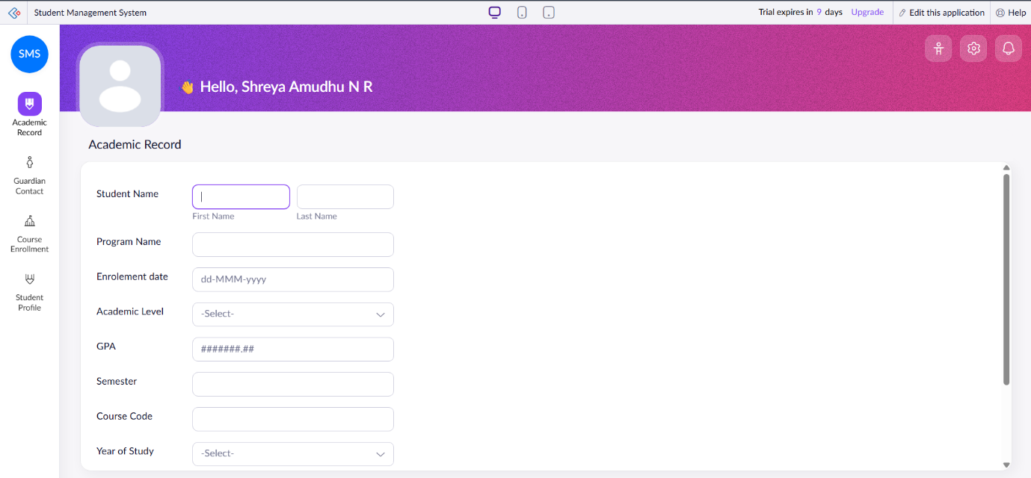
Academic Record Form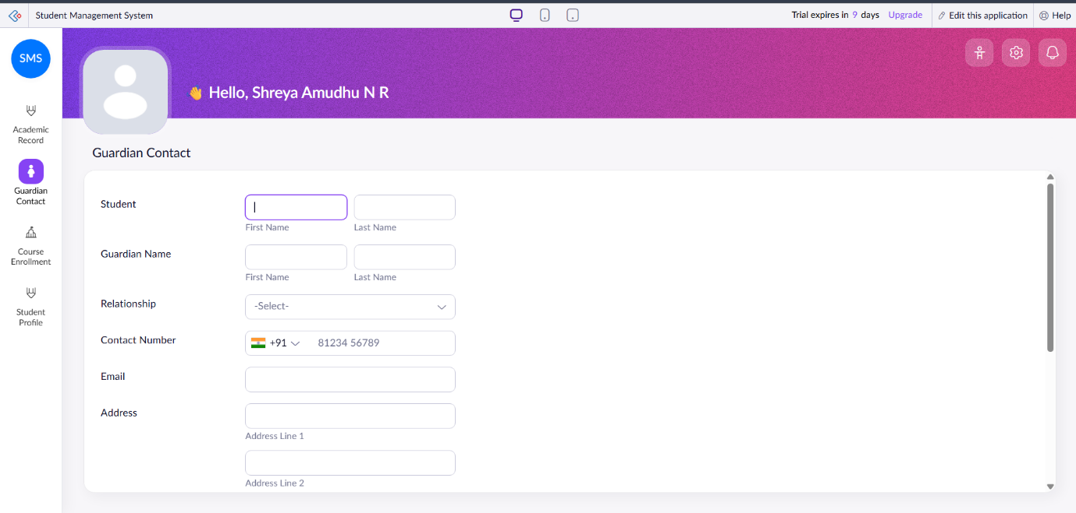Guardian Contact Form
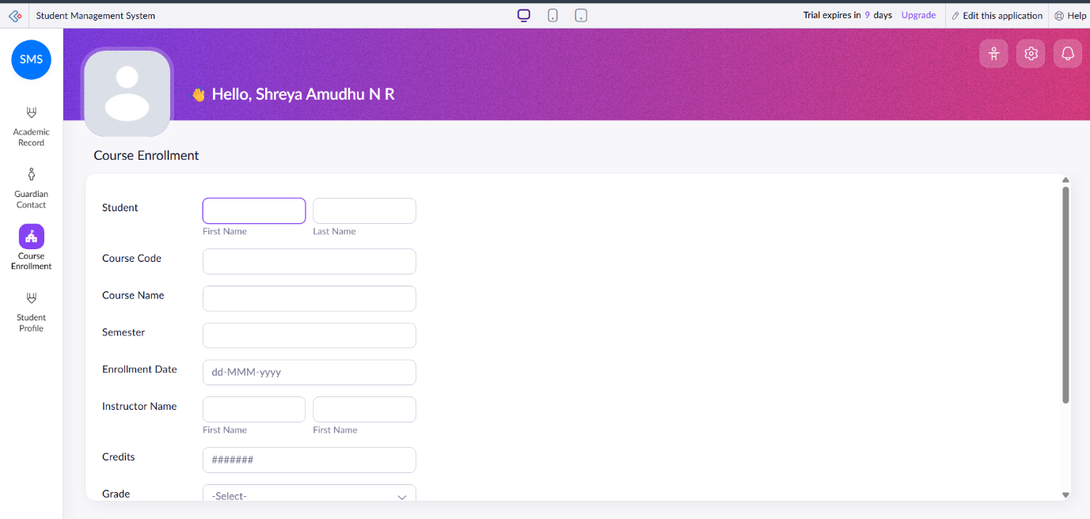
Course Enrollment Form
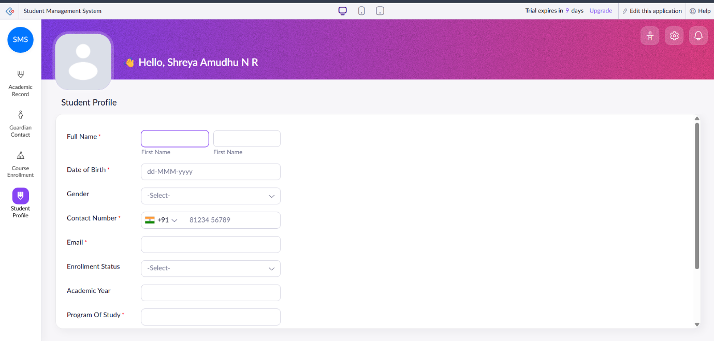
Student Profile Form
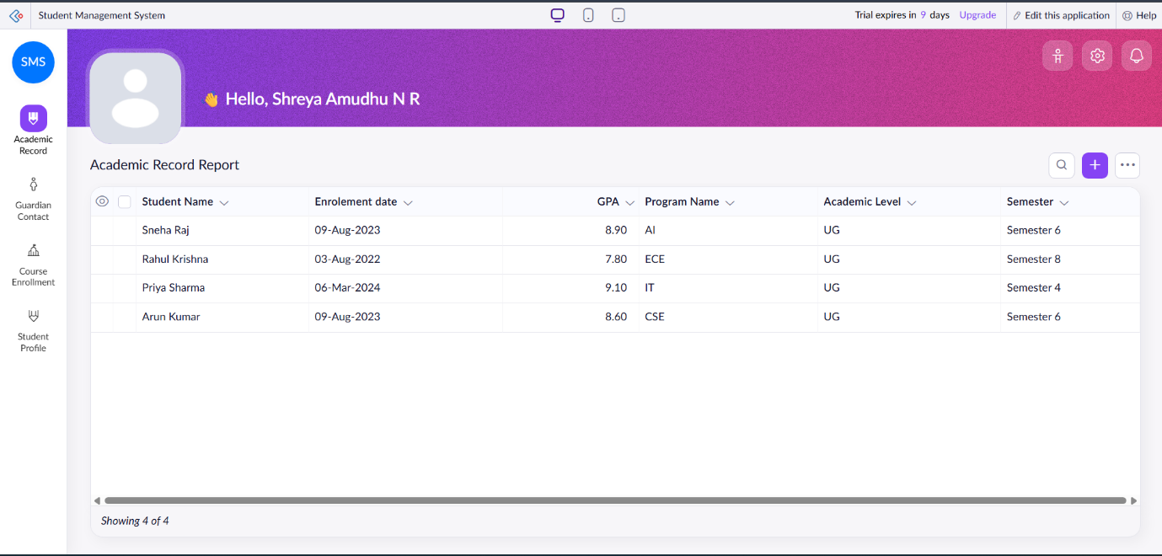
Report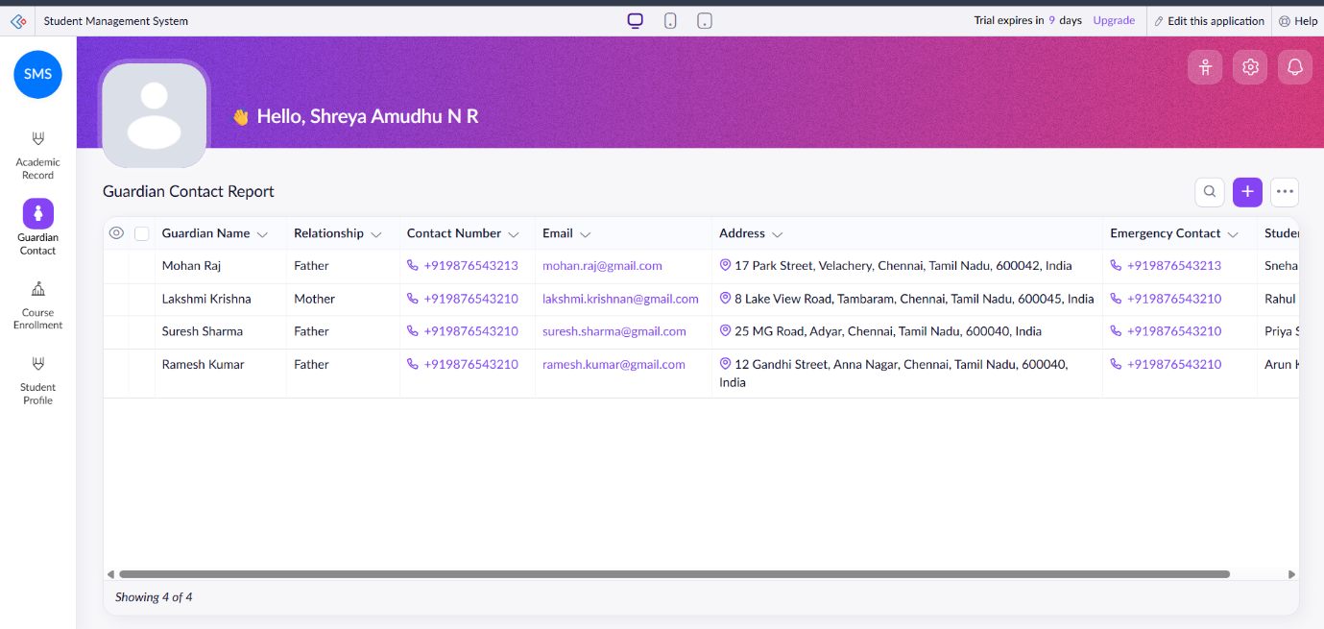
Report
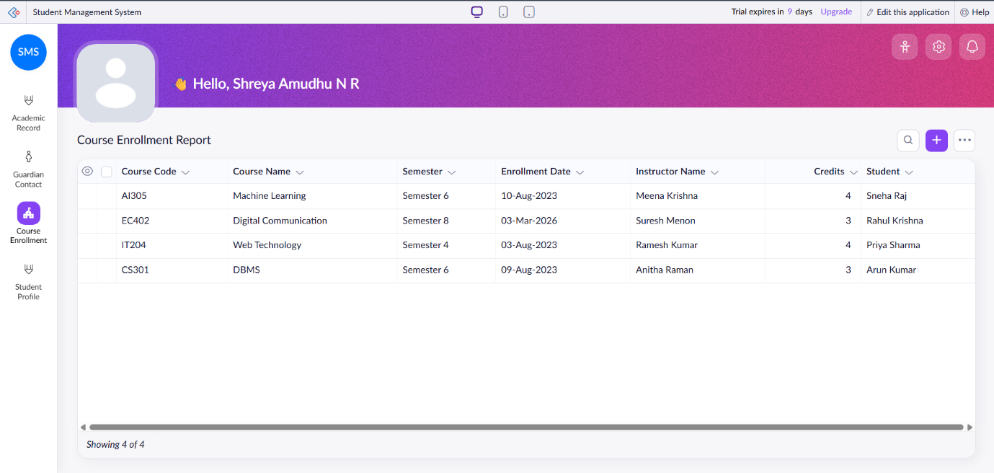
Report
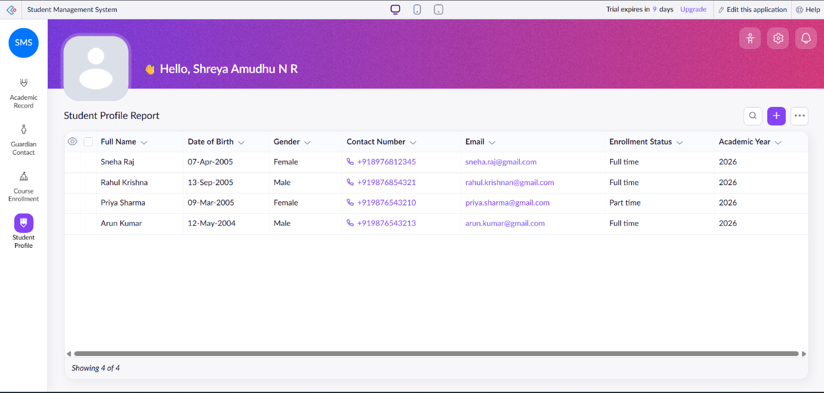
Result
Successfully created a Student Management System in Zoho Creator by manually designing multiple forms without using the Zia AI assistant. The application allows users to enter and manage student profiles, academic records, course enrollment information, and guardian contact details efficiently using Zoho Creator's low-code development environment.

